12282019 Notes on DSC Functional Form

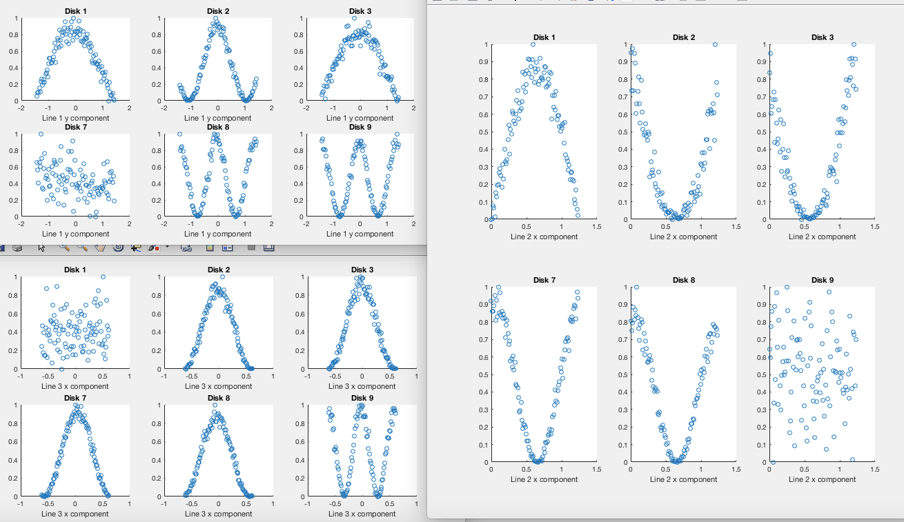

Here are relevant blinking plots, where we have probed three lines.

Line 1 traces out the first DSC lattice vector direction.

Line 2 runs from the first DSC lattice vector to the second DSC lattice vector.

Line 3 runs from the saddle point in between DSC 1 and DSC 2 lattice vectors.

Throughout, this is defined as DSC 1 is straight up and DSC 2 is up and to the right on a regular hexagon.

Those plots weren’t very good: see the revised ones here:

The results from using the trig fitting (first try):

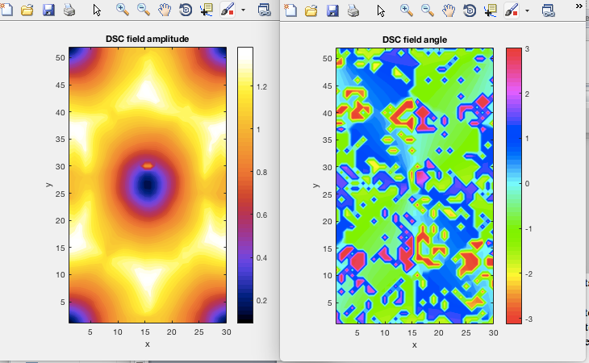

This is really kind of bizarre. What’s up with that?

Indeed the angle of the vector field is a complete mess:

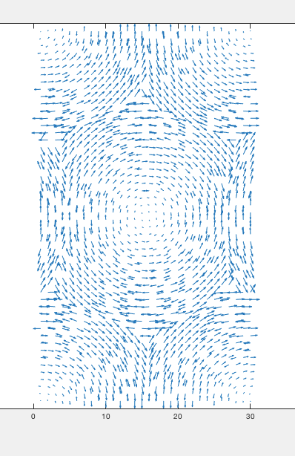

Seems like the contour plot is botching it? But why are the arrows sometimes flipping the wrong direction anyways? Seems like that may be a fit issue, since the DSC lattice isn’t symmetric. Maybe try again with the penalized function; could be on account of that. Or fmincon.

But notice that the vortices are now spinning in the same direction. Something more fundamental is the issue here.

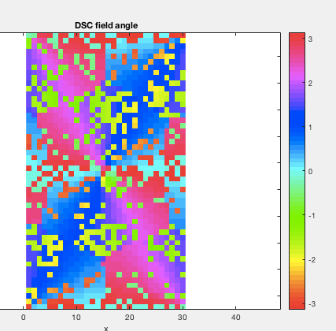

Switching back to the interpolated fitting function, things seem fine:

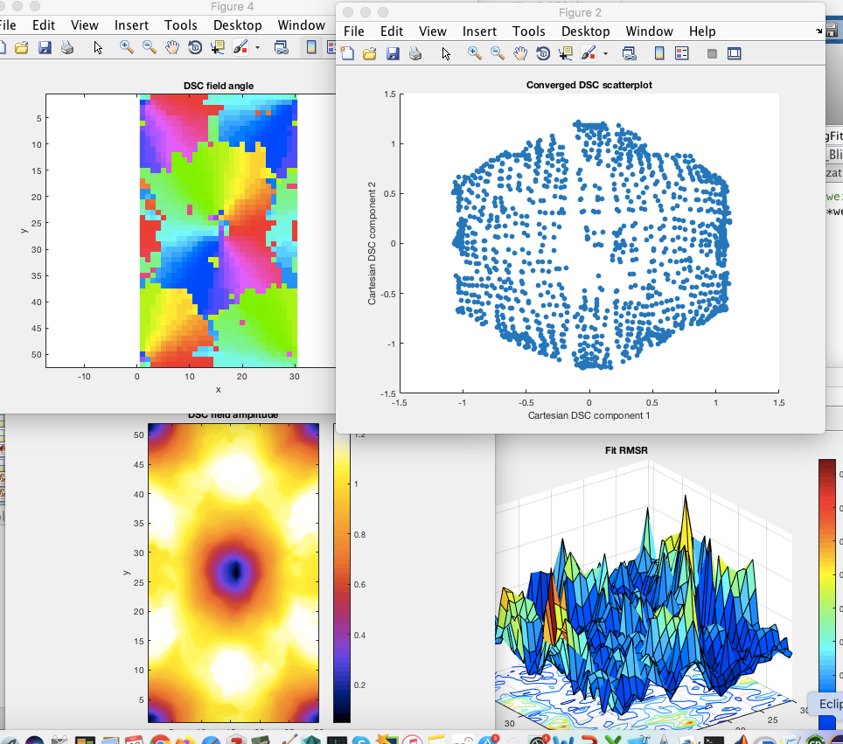

Notice, though, that the times when the trig fitting function failed to give the right angle were connected to an inability to find negative optimal angles. So this may mean there is some sort of a problem either in the function or in optimizer regarding such. Otherwise, it doesn’t make sense for the residuals to be so small.

* Perhaps it could be the projection vectors. Maybe I need to make them exactly the same for, say, disks 1 and 4, rather than the negative of each other. The effect of the negative is to flip the sign of the projection. Perhaps this is introducing an ambiguity somehow?

Have the same as before re-running the fit with trig, suggesting an ambiguity problem exists.

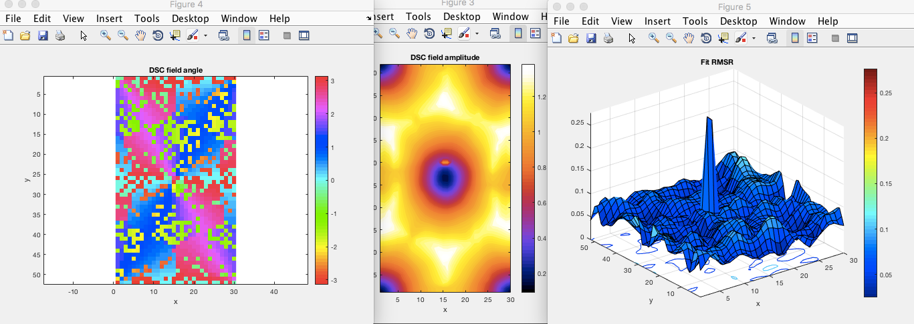

Flipping the projection vector signs doesn’t help:

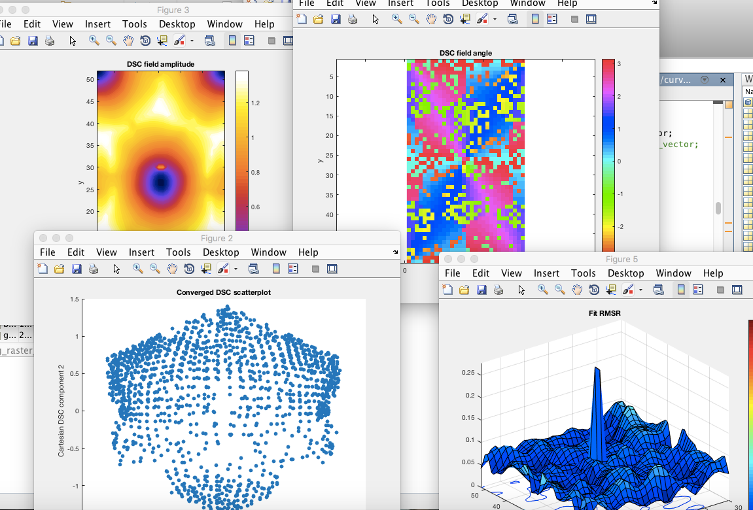

So I think the theoretical answer is that there’s no way to distinguish positive versus negative DSC vectors except on the basis of some hBN effect. Can try some ED simulations later to prove this, but if I constrain all positive angles, this should start working.